RESUME

SANJAY KUMAR
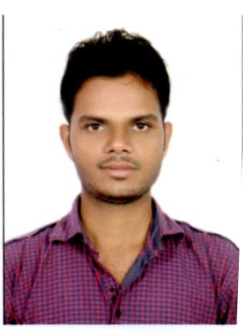

Hinouta near Shiv Mandir,
NMDC Majhagawan
Panna (MP) 488101 INDIA
E-mail -sensanjay86@gmail.com
Mobile no: +91 9755574302,
+917692071100

CAREER OBJECTIVES

To achieve a challenging position in an organization where I can maximize my technical skills and contribute for the betterment of the organization

Work experience:

Reliance Jio Infocomm Pvt Ltd (on payroll of Kutumbh Care Pvt Ltd)from 16th feb. 2015 to 30th April 2016.
- Worked with HEG Ltd. as a supervisor under Contractor (From July 2010 to till 6 months)

MEASURE AND MINOR TRAINING

- I have done 30 days training in Appin Tech. Bhopal (mp)
- I have done 15 days training in PLC Programming and Application from CRISP BHOPAL
- I have done 15 days training in Scienetech Learning Center Indore (mp)

PROJECTS
B.E. Project: Prepaid Energy Meter.
Prepaid Energy Meter project brings in the innovative concept of prepaid electricity. Advancements in technology have been on the upsurge since a decade. Electricity bills can be now saved with the press of button on your computer.
Diploma Project: UPS System.
An uninterruptible power supply, also uninterruptible power source, UPS or battery backup, is an electrical apparatus that provides emergency power to a load when the input power source, typically mains power, fails. A UPS differs from an auxiliary or emergency power system or standby generator in that it will provide near-instantaneous protection from input power interruptions, by supplying energy stored in batteries, super capacitors
EDUCATION
- B.E. (Electronics & Communication Engineering.) from Surabhi College of Engineering & Technology, Bhopal (RGPV, Bhopal) with 6.84 CGPA in 2014.
- 3 years Diploma (Electronics & Communication Engineering.) from S.V. Polytechnic College, Bhopal with 61.3% of marks in 2010.
- 12th (PCM) from MP Board with 64.2% of marks in 2007.
- 10th from MP Board with 52.8% of marks in 2004.

SOFTWARE SKILLS
- Skill set: Basic knowledge of Computer.

ACCOMPLISHMENTS

- Participation in District level volleyball shooting in School time.

PERSONAL

- Fathers Name: Shri.Munni Lal Sen
- Gender: Male.
- Mothers Name: Shrimati Vidya Sen
- Marital Status: married
- Date Of Birth: 22/02/1989
- Languages Known: Hindi and English
- Hobbies: Playing volleyball and listening songs.

DECLARATION

I hereby declare that the above given information is true to the best of my knowledge.

Date:
PANNA (M.P) Sanjay Kumar

